Macintosh HD:Users:katielam:Desktop:logo.gif **Hong Kong Institute of Vocational Education**

**ITP4506 Human Computer Interaction and GUI Programming**

**E-commerce Website**

|  |  |  |  |
| --- | --- | --- | --- |
| **Student ID** | **Name** | **Contribution** | **Signature** |
| 160450066 | LamKitYu | 50% |  |
| 160548082 | YauTsunSing | 50% |  |

Table of Contents

1. Background 1

2. User Analysis 2

2.1. Learning style 2

2.2. Tool preferences 2

3. Web Concept 3

4. User Interface design 4

4.1. Home Page 4

4.2. Hotel page 6

4.3. Flight page 8

4.4. Register/Login Page 10

4.5. Shopping Cart page 11

# Background

The Happy Travel Ltd is a medium-sized travel agent. This company want to build a website for the tertiary student in Hong Kong. First, the website user interface should be user-friendly.

# 2. User Analysis

## 2.1. Learning style

## 

## 2.2. Tool preferences

# Web Concept

# User Interface design

## 4.1. Home Page

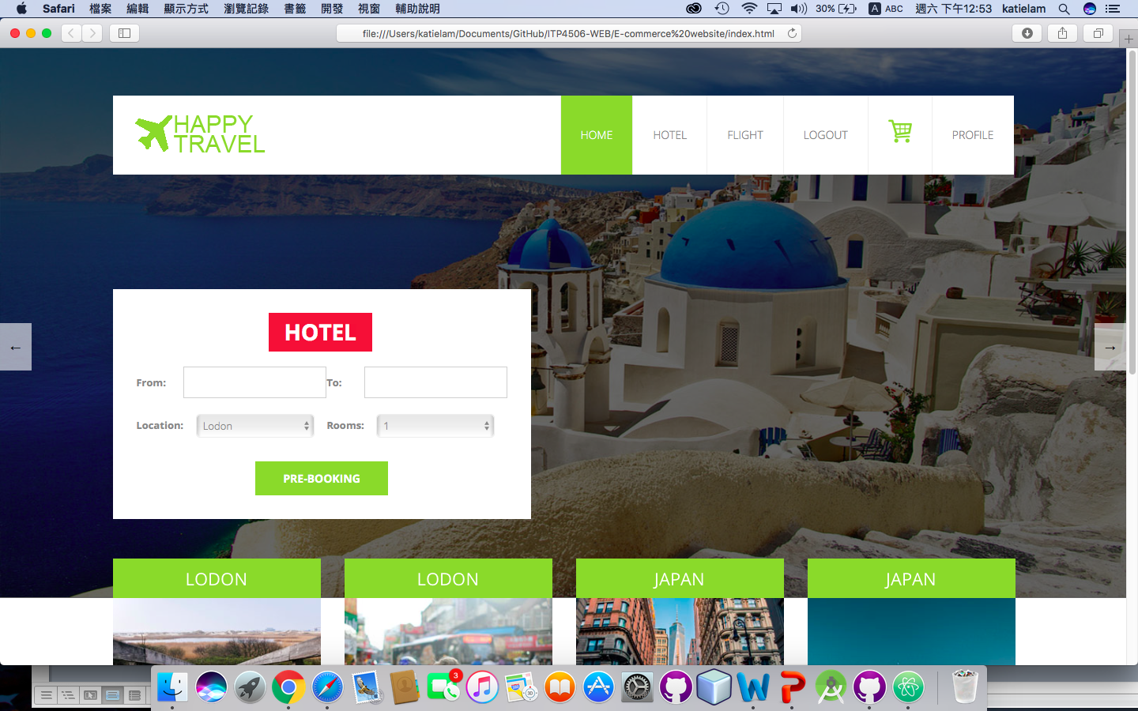

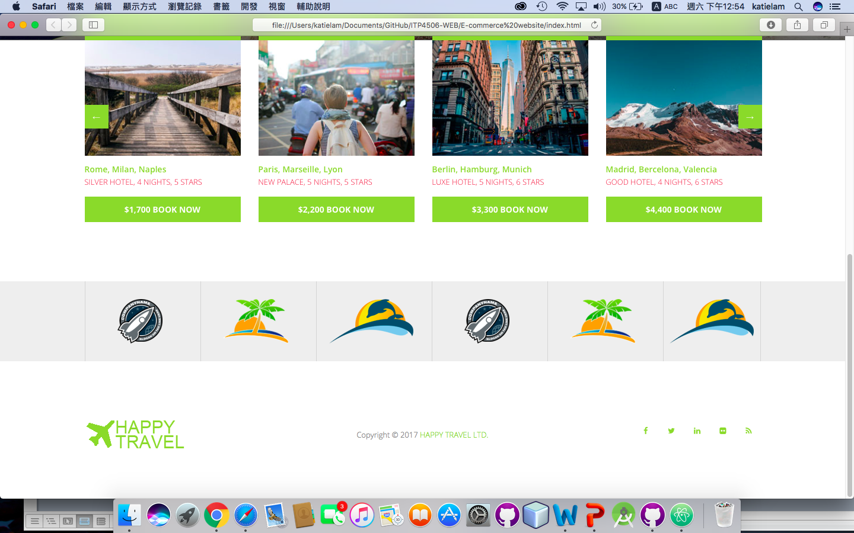

## 4.2. Hotel page

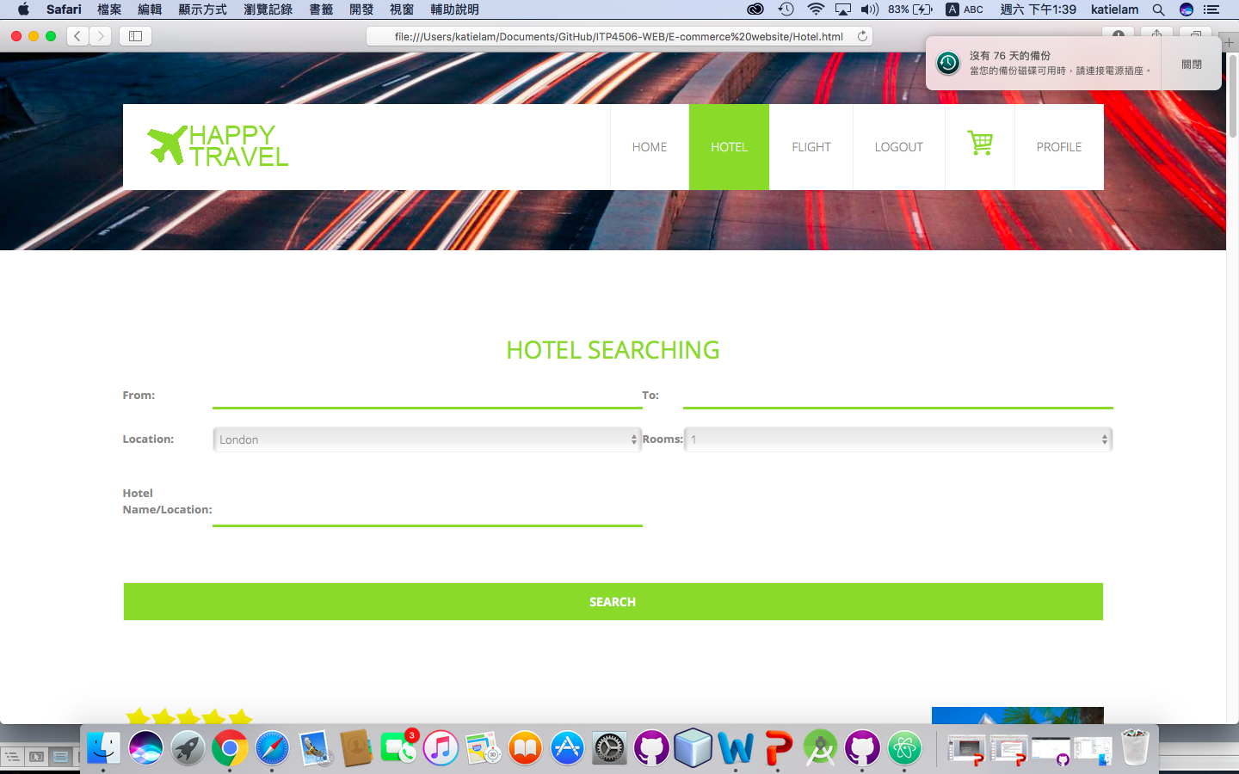

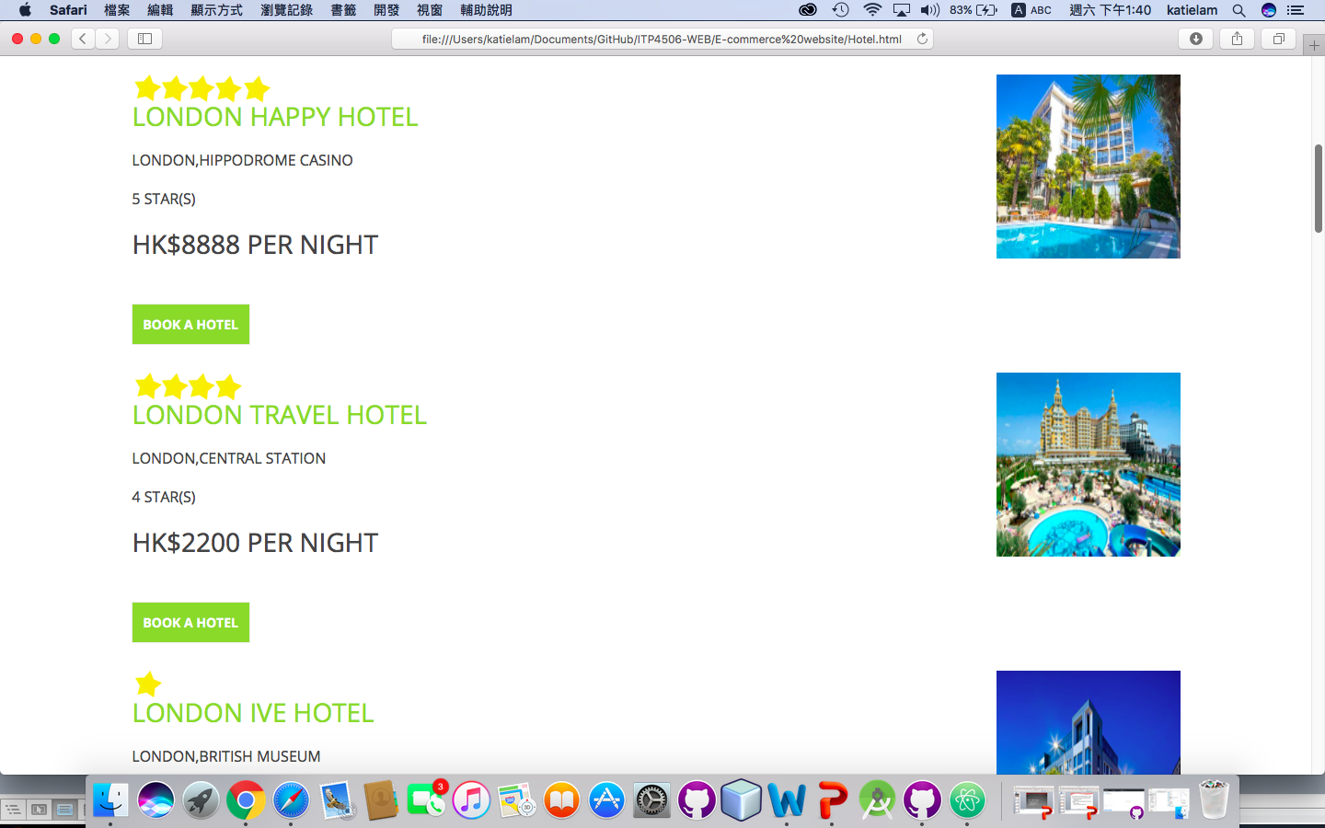

## 4.3. Flight page

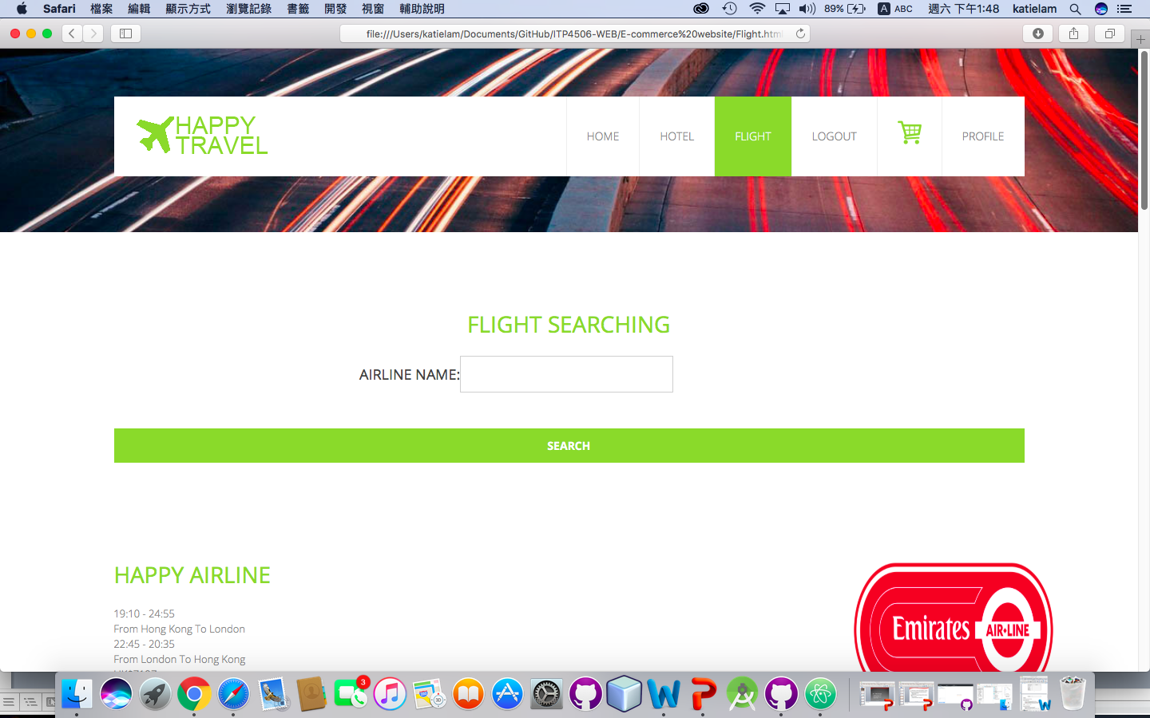

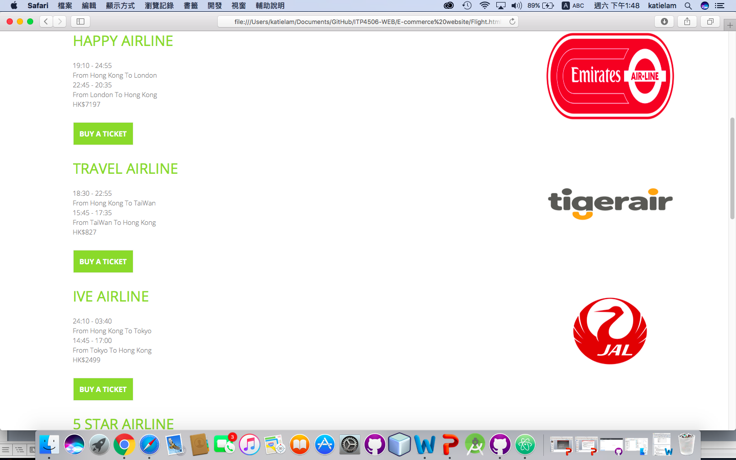

## 4.4. Register/Login Page

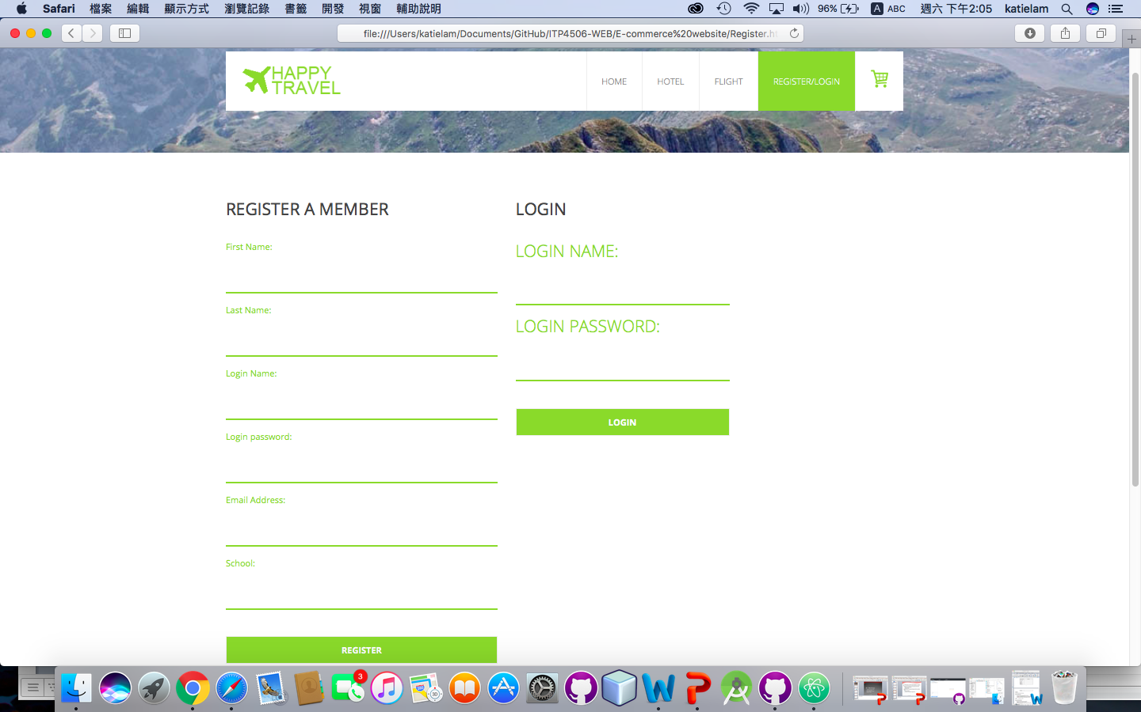

## 4.5. Shopping Cart page